📌 **Cleaned the Dataset and Converted Categories into Structured Format**

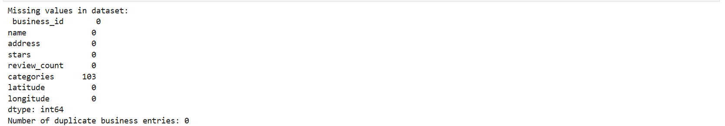

📌 **Using Database Yelp**

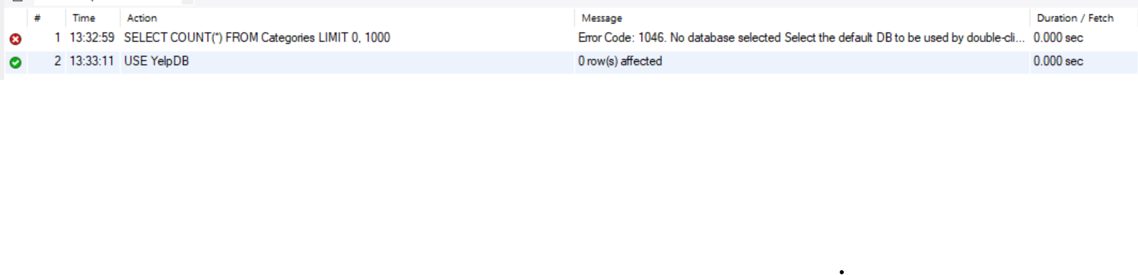

📌 **Unique Categories Table**

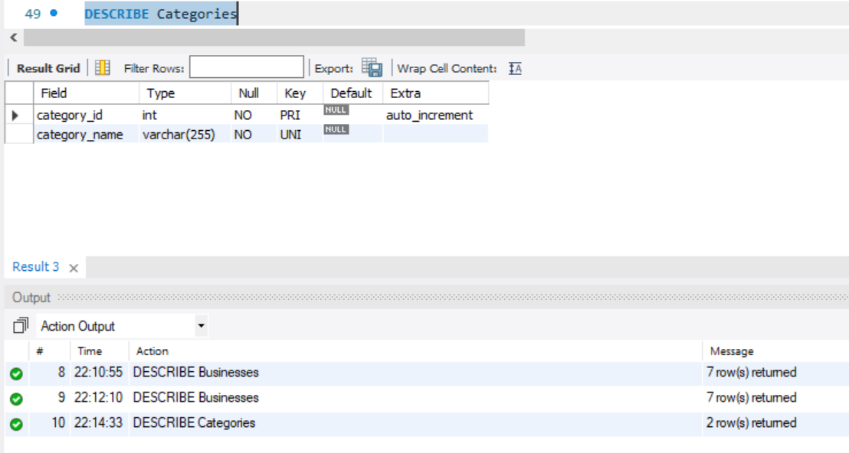

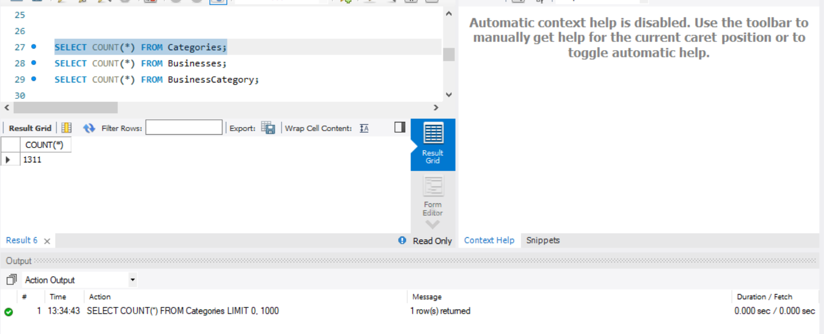

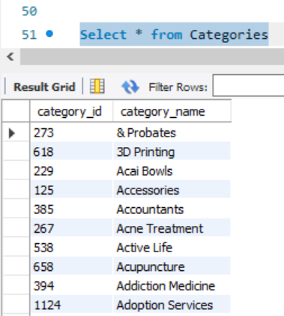

📌 **Total Businesses in Business Table** 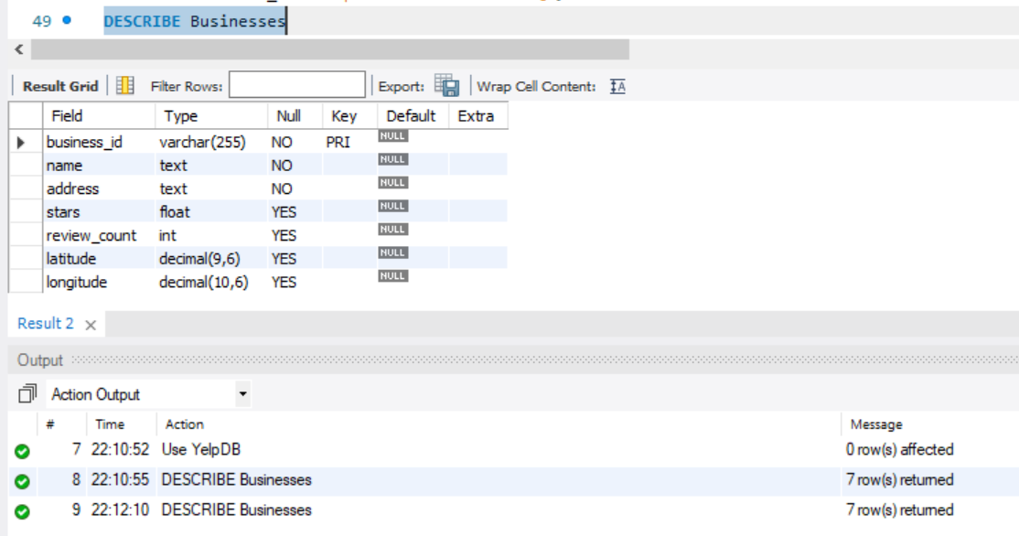

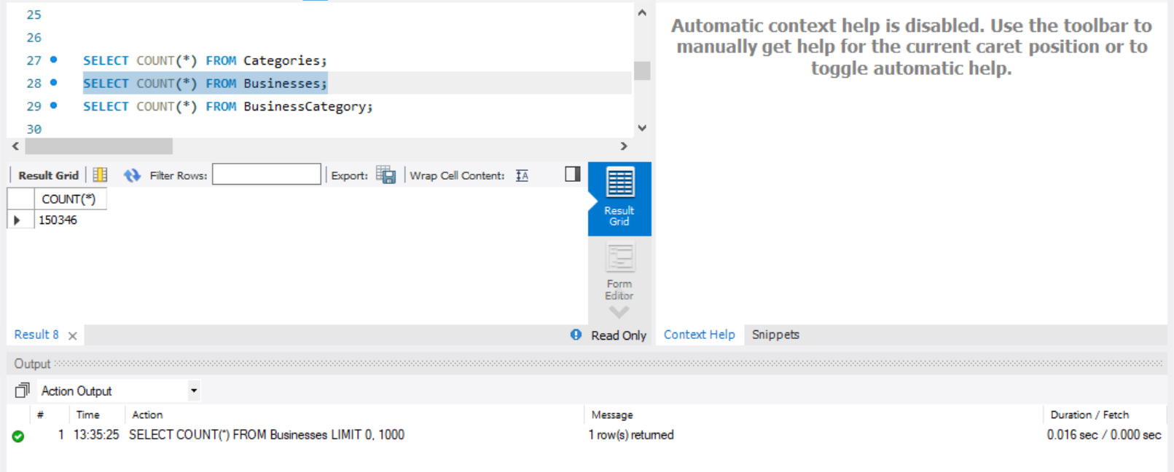

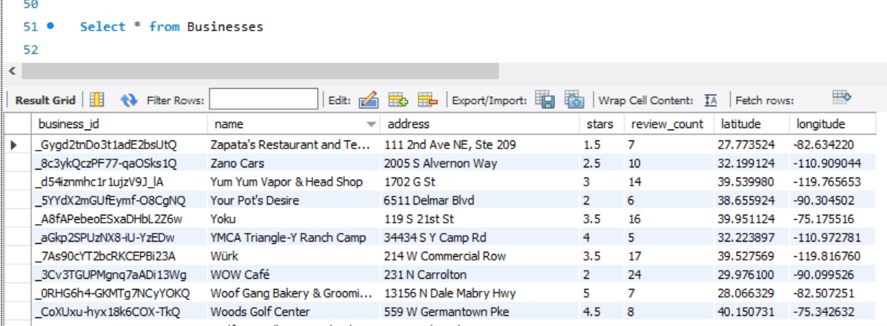

📌 **BusinessCategory Table for Mapping b/w Businesses Table and Categories Table**

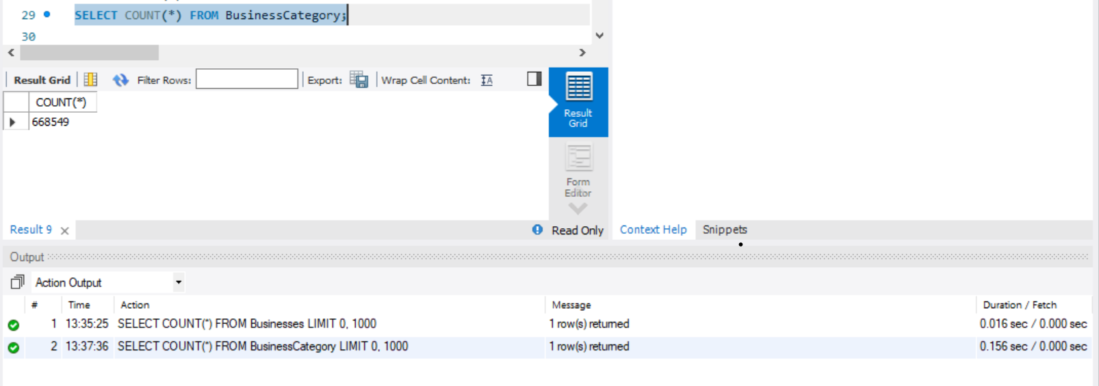

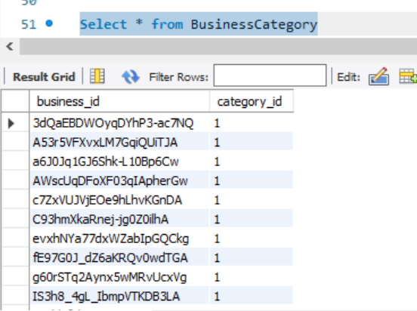

📌 **Based on some Business Id I checked Categories and verified with CSV File**

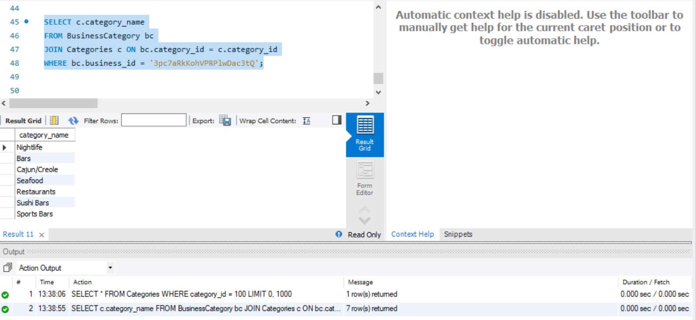

📌 **CSV File**



📌 **Constraint Test**

1. Negative Rating

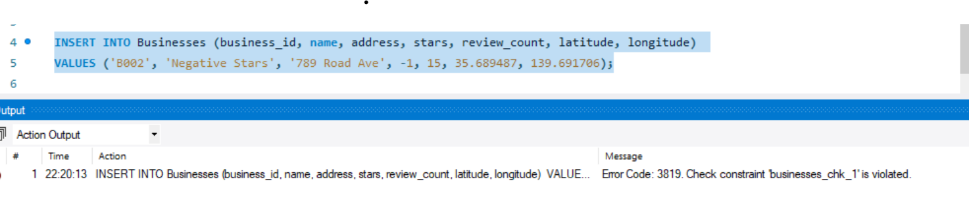

1. Negative Review Count

